**Mesh Current Analysis using PSPICE**

**Objective of Lab:-**

1. Mesh Current Method.
2. Verifying Mesh Current Method.

* Using PSPICE.
* Mathematically.

**Mesh Current Analysis:-**

Mesh analysis (or the mesh current method) is method that is used to solve planar circuits for the currents (and indirectly the voltages) at any place in the electrical circuit. Planar circuits are circuits that can be drawn on a plane surface with no wires crossing each other.

# Steps of Mesh Analysis:-

**S**

**t**

**e**

**p**

**1**

I

d

e

n

t

i

f

y

t

h

e

n

u

m

b

e

r

o

f

b

a

s

i

c

m

e

s

h

e

s

.

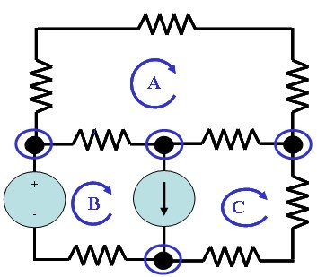

**S**

**t**

**e**

**p**

**2**

A

s

s

i

g

n

a

c

u

r

r

e

n

t

t

o

e

a

c

h

m

e

s

h

.

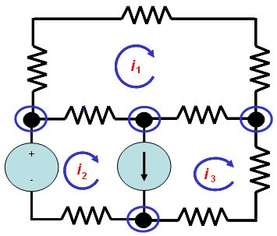

**S**

**t**

**e**

**p**

**3**

A

p

p

l

y

K

V

L

a

r

o

u

n

d

e

a

c

h

l

o

o

p

t

o

g

e

t

a

n

e

q

u

a

t

i

o

n

i

n

t

e

r

m

s

o

f

t

h

e

l

o

o

p

c

u

r

r

e

n

t

s

.

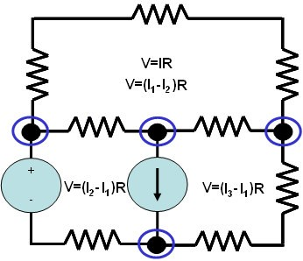

**S**

**t**

**e**

**p**

**4**

S

o

l

v

e

t

h

e

r

e

s

u

l

t

i

n

g

s

y

s

t

e

m

o

f

l

i

n

e

a

r

e

q

u

a

t

i

o

n

s

.

A

s

a

n

e

x

a

m

p

l

e

*V*

*1*

*+*

*I*

*1*

*R*

*1*

*+*

*(*

*I*

*1*

*-*

*I*

*2*

*)*

*R*

*3*

*=*

*0*

*I*

*2*

*R*

*2*

*+*

*V*

*2*

*+*

*(*

*I*

*2*

*-*

*I*

*1*

*)*

*R*

*3*

*=*

*0*

**Circuit Diagram:-**

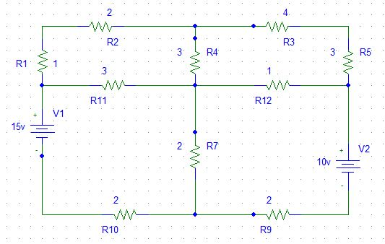

I4

I3

I2

**I1**

**CIRCUIT DIAGRAM USING PSPICE:-**

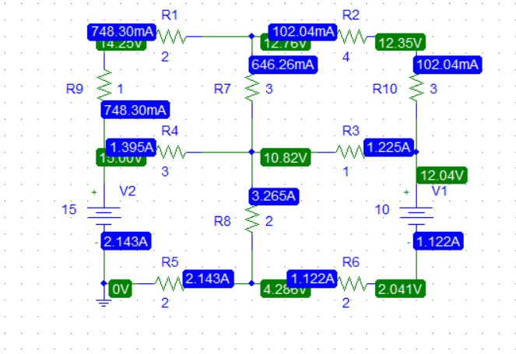

**OBSERVATIONS AND CALCULATION:**

**mesh# 01**

-15 +3(I1-I2) + (I1-I2) +2 I1

3I1 - 3 I2 + 2 I1- 2 I4 + 2I1 =15

7 I1 – 3 I2 – 2 I4=15

**mesh# 02:**

1 I2 + 2 I2 + 3(I2- I1 ) + 3(I2 – I3)

1 I2 + 2 I2+ 3 I2 - 3 I1 + 3 I2 - 3 I3

9 I2 - 3 I1 - 3 I3 =0

**mesh# 03:**

3(I3- I2) + 4 I3 + 3 I3 + 1(I3 - I4)

3I3- 3I2 + 4 I3 + 3 I3 + 1I3 - 1I4

11I3 – 3 I2 - 1 I4 =0

**mesh# 04:**

2(I4- I1) +1(I4- I3) +2I4 =10

2I4- 2I1 +1I4- 1I3 +2I4

-1I3 + 2 I4 - 2I1 =-10

write in matrix form:

7 -3 0 -2 I1 15

-3 9 -3 0 I2 **=**0

0 -3 11 -1 I3  0

-2 0 -1 2 I4 -10

**result:**

I1 = 2.14a

I2 =748.30mA

I3 =102.04 mA

I4 =1.122a

**CONCLUSION**

In accordance with the mesh analysis, we made use of Kirchoff’s law to arrive at a system of equations which aims to calculate the currents.

**ASSESSMENT RUBRICS LAB # 8**

**Mesh Current Analysis using PSPICE**

|  |  |  |  |  |
| --- | --- | --- | --- | --- |
| **LAB REPORT ASSESSMENT** | | | | |
| **Criteria** | **Excellent** | **Average** | **Nill** | **Marks Obtained** |
| 1. **Objectives of Lab** | All objectives of lab are properly covered  [Marks 0.5] | Objectives of lab are partially covered  [Marks 0.25] | Objectives of lab are not shown  [Marks 0] |  |
| 1. **Mesh Current Analysis**   **(Theory, Circuit Diagram )** | Brief introduction about Mesh Current Analysis (what is Mesh current analysis, What are meshes, How to apply KVL equations in each mesh) is shown along with properly labeled circuit diagram  [Marks 1] | Some of the points about Mesh Current Analysis are missing and circuit diagram is not properly labeled  [Marks 0.5] | Introduction about Mesh Current Analysis and circuit diagram is not shown  [Marks 0] |  |
| 1. **PSPICE**   **Simulator** | Brief introduction of PSPICE simulator  [Marks 1] | Brief introduction of PSPICE simulator  Is not shown  [Marks 0] | |  |
| 1. **Procedure** | All experimental steps are shown in detail along with how to verify Mesh Current Analysis.  [Marks 1.5] | Some of the experimental steps are missing  [Marks 1] | Experimental steps are missing  [Marks 0] |  |
| 1. **Observations & Calculations** | Mathematical calculations are shown and comparison with PSPICE results.  [Marks 5] | Mathematical calculations are shown but no comparison with PSPICE results  [Marks 2.5] | No mathematical calculations are shown  [Marks 0] |  |
| 1. **Conclusion** | Conclusion about experiment is shown  [Marks 1] | Conclusion about experiment is partially shown  [Marks 0.5] | Conclusion about experiment is not shown  [Marks 0] |  |
| Total Marks Obtained:__________  Instructor Signature: ______________________ | | | | |

**CIRCUIT SYSTEM-1**

**LAB # 8**



**Submitted By: Shah Raza**

**Registration# 18PWCSE1658**

**Section: “B”**

**Batch “20”**

**Submitted To: Engr.Muniba Ashfaq**